**Chapter 3**

**System Analysis**

**3.1 Study of Current System and Requirement of this System**

**Current System:-**

* It is not user friendly.
* Person have to pay for the consultation
* Villagers cannot afford the rate of the consultation fees
* Complicated formats
* Can’t add multiple pets

**Our System: -**

* It is user friendly
* Person can choose which doctor he/she wants whether private doctor or government doctor
* If person chooses government doctor, he/she doesn’t need to pay the consultation fee
* Can access their previous data
* Location wise options

**3.2 Data Dictionary**

Pet Table

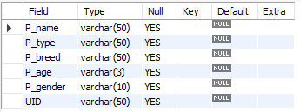

Doctor Table



Set Appointment Table

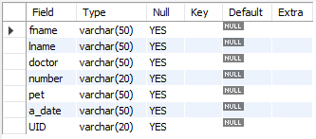

Records Table

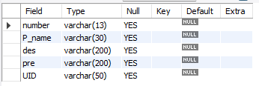

User Table

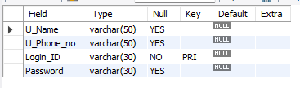

**3.3 Modules and Their Description of System**

There is one module in our project:

1. USER MODULE: In this module user can login into the website if he/she is not registered then user has to register first and then login into the website and after that person can add their pets and set appointments for their pet and if they want they can check their scheduled appointments and can see his/her pets previous medical records.